Learning Experience Plan
Subject: Spanish Grade level: Middle School
Unit: Present Tense Verbs Length of LEP (days/periods/minutes): 45 minutes
Topic: Ser
Content Standards:
Standard 1: Students will be able to use a language other than English for communication.
Key Idea: READING & WRITING are used in languages other than English for the purposes of socializing, providing and acquiring information, expressing personal feelings and opinions, and getting others to adopt a course of action.
Checkpoint A
  - understand the main idea and some details of simple informative materials written for native speakers
  - compose short, informal notes and messages to exchange information with members of the target culture
Key Idea: LISTENING & SPEAKING are primary communicative goals in modern language learning. These skills are used for the purposes of socializing, providing and acquiring information, expressing personal feelings and opinions, and getting others to adopt a course of action.
Checkpoint A
- Comprehend language consisting of simple vocabulary and structures in face-to-face conversation with peers and familiar adults.
- call upon repetition, rephrasing, and nonverbal cues to derive or convey meaning from a language other than English
Standard 2: Students will develop cross-cultural skills and understandings.
Key Idea: EFFECTIVE COMMUNICATION involves meanings that go beyond words and require an understanding of perceptions, gestures, folklore, and family and community dynamics. All of these elements can affect whether and how well a message is received.
Checkpoint A
- use some key cultural traits of the societies in which the target language is spoken
Literacy Standards: (include only standards addressed in this LEP)
Speaking and Listening Standards: Comprehension and Collaboration
- Engage effectively in a range of collaborative discussions (one-on-one, in groups, and teacher-led) with diverse partners on grade 6 topics, texts, and issues, building on others’ ideas and expressing their own clearly.
- Pose and respond to specific questions with elaboration and detail by making comments that contribute to the topic, text, or issue under discussion.
- Seek to understand and communicate with individuals from different perspectives and cultural backgrounds.
Language Standards: Conventions of Standard English/Spanish & Knowledge of Language
- Demonstrate command of the conventions of Standard English/Spanish grammar and usage when writing or speaking.
- Ensure that pronouns are in the proper case (subjective, objective, and possessive).
- Recognize and correct inappropriate shifts in pronoun number and person.
- Recognize and correct vague pronouns (i.e., ones with unclear or ambiguous antecedents)
- Use knowledge of language and its conventions when writing, speaking, reading, or listening.
  - Vary sentence patterns for meaning, reader/listener interest, and style.
  - Maintain consistency in style and tone.

Learning Experience Outcomes  Students will:  - Students will know the three different types of verbs in order to conjugate correctly  - Students will know the verb endings in order to correctly conjugate a verb based on the subject  - Students will know the subject pronouns in order to use them correctly with a conjugated verb  - Students will say vocabulary in order to pronounce words correctly.  - Students will write vocabulary in order to spell correctly  - Students will know how to conjugate verbs in order to express what they do. |  |  | Learning Experience Assessments  Students will:  - Students will write sentences in Spanish using ser  - Students will describe themselves and friends using ser  - Students will use correct grammar and sentence structure
Differentiation (What will you do to meet the needs of students at these different levels?)
Approaching Students who are approaching will work in pairs with me or a native speaker of Spanish so they can be scaffold to a better understanding |  | On-level These students will follow the plan as intended |  | Beyond Native speakers of Spanish will serve as guides for this lesson plan. They give insight on to how the use Ser in their own daily lives.
Curriculum Integration (Does this lesson correlate with any other content area? Describe.)

Materials | Procedures/Strategies
Day 1
Sponge Activity: Students will listen to Como la flor by Selena to hear a Mexican Pop song
Anticipatory Set: Students will participate in Sí o No which I will ask them various questions about conjugated verbs. For example is Comes plural and students will left a paddle that indicates sí for yes or no for no.
Activating Prior Knowledge: I will ask students to conjugate thee verbs that end in –AR, ER or IR based on the person and number they select from a bag.
Direct Instruction: Firstly I will explain how the verb Ser is irregular because it does not follow a fixed conjugation. The verb Ser is conjugated as the following
Ser- to be
Yo soy Nosotros/as somos
Tú eres Vosotros/as sois
Él, Ella, Usted es Ellos/Ellas, Ustedes son
Cultural: Explain how vosotros is only used in Spain for the fimilar tú while in Latin America Ustedes is used.
Explain that Ser is used for for “Descrpition, Occupation, Characteristics, Time, Origin, and Relationship. This is known as D.O.C.T.O.R
Guided Practice: Together as a class we will complete the following questions
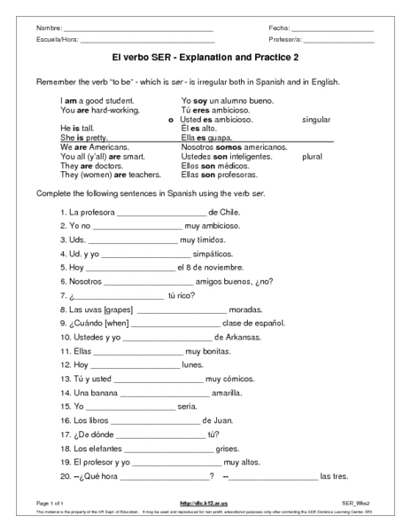

Independent Practice: Students will come up with five sentences for the D.O.C.T.O.R pneumonic device.
Closure: Explain that tomorrow’s lesson will be “Estar” which is also to be but is used in different context.

