Lesson Plan  #_1_ of #_1_ | NYS/National  Standards | Teacher Candidate(s): Maeve Parahus | School: Intech Academy | Date: April 15, 2016  Grade: 8th Grade  # in class: 24 Students
 |  | Unit/Activity: Rugby
 |  | Central Focus and Lesson Focus: Throwing and Catching
 |  | Link to previous lesson(s): Linked to last lesson on Football
 |  | Objectives – Students will be able to……..  Behavior / Condition / Criteria | Assessment Tool | Length of class: 11:15-12:00  (changing-11:15-11:25)(changing-11:50-12:00)  About 25 minutes of class time
Objective #1  Domain: Cognitive | / | Students will be able to understand the differences and similarities between the game of Rugby and a game of Football. |  | Teaching Styles/Strategies:  - Direct Teaching  - Teachers Feedback
Objective #2  Domain: Psychomotor | / | Students will be able to correctly execute a pass and a catch
Objective #3  Domain: Affective | / | Students will be able to demonstrate proper behavior that is consistent with the “safe” guidelines outlined by the teacher
List of Academic Language Used | Vocabulary  words | Comparing, Similarity, Differences, Venn Diagram |  | Equipment:  - Rugby Balls  - Footballs  - Ladders  - Cones  - Flags
Language  Function/Common  Core | Examples: analyze, compare, evaluate, sequence, signal, & summarize | Students will be able to compare the similarities and differences between a Rugby game and a Football game. They will be completing a Venn diagram based off a video they watched about each sport. Then they will go into the gymnasium to talk about the similarity and differences and figure out which works best through demonstration within their assigned groups.
Safety Statement | 2c/4 |  | References(e.g. Book, course packet, pg #, complete web address URL):
 |  |  | http://www.supportrealteachers.org/teaching-styles-in-physical-education.html
NYS Learning Standard 1 – Personal Health and Fitness  1A. Students will perform basic motor and manipulative skills. Students will attain competency in a variety of motor and sports activities.  1B. Students will design personal fitness programs to improve cardio respiratory endurance, flexibility, muscular strength, endurance, and body composition  NYS Learning Standard 2– A Safe and Healthy Environment  2a. Students will demonstrate responsible personal and social behavior while engaged in physical activity.  2b. Students will understand that physical activity provides the opportunity for enjoyment, challenge, self-expression and communication.  2c. Students will be able to identify safety hazards and react effectively to ensure a safe and positive experience for all participants.  NYS Learning Standard 3– Resource Management  3a. Students will be aware of and able to access opportunities available to them within their community to engage in physical activity.  3b. Students will be informed consumers and be able to evaluate facilities and programs.  3c. Students will also be aware of career options in the field of physical fitness and sports |  |  | National Standards – The physically literate individual:  1. Demonstrates competency in a variety of motor skills and movement patterns.  2. Applies knowledge of concepts, principles, strategies and tactics related to movement  and performance.  3. Demonstrates the knowledge and skills to achieve and maintain a health-enhancing  level of physical activity and fitness.  4. Exhibits responsible personal and social behavior that respects self and others.  5. Recognizes the value of physical activity for health, enjoyment, challenge, self-  expression, and/or social interaction.

Time | Task | Description/Organization | Diagram | Cues | Adaptations/Modifications
5 minutes  10 minutes  15 minutes  5 minutes | Introducing Rugby and Introducing Football  (Set up Stations)  Get into groups of 5- Talk about similarities and differences  Demonstrate  Conclusion | Students will all be in the classroom. I will have them watch videos on a rugby game and a football game. They will be given a Venn diagram to fill out of comparing the two sports similarities and differences.  Students will get into groups of 5. We will go to the gymnasium and each group will talk about which similarities and differences they noticed by watching the videos.  Within their groups students will talk about the different strategies each team used during these two sports. They will then physically demonstrate them and talk about what would work best in a game-like situation, and know the similarity and differences between each play.  Students will show me they know the similarities and differences by each group getting a poster board. They will combined what they learned in class, and through the video’s to fill out the diagram more in depth, including what works best after physically doing the movements. | Example of a Venn Diagram: | Cues For both Rugby and Football  - Hands together  - Give with the ball (cushion)  - Step in the direction your passing  - Follow through

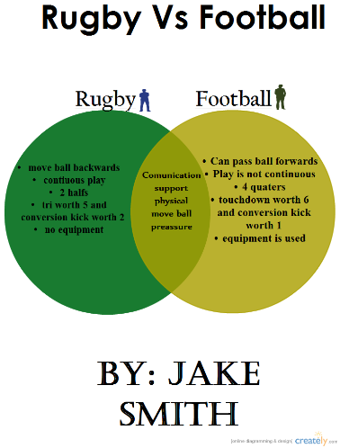
Scenario 3 Differentiation to the Lesson Plan:

If I were to use this lesson in a multicultural student body I would have to make some adjustments to the lesson. Modifications should be made if in a class where the students generally read below grade level, and some levels even being three, four, or more years below the grad level. As a teacher of a physical education classroom with many students below reading level, I must be aware that some of my students might not grasp the material. I think using collaborating groups would help these kids that may be below the average level. The lower level readers may not want to speak that much in fear of being wrong. I would have reachable standards for these students and I would make them rise to these expectations, and eventually exceed them. To make sure everyone is participating the group discussions on these sports, I will use the sport education model of teaching. I will assign groups of five so they are all about equal. I would put two lower level readers, two average level, and one student who excels. Each student will be given a role in the group on which movements they should research, or know more about. This model will essentially keep everyone involved in the activity, even ones that might be on the lower level of reading. Also I would make sure I identified all the vocabulary words within the lesson that may be unfamiliar to the students. This will help them better understand the video and the comparisons between Rugby and Football. If I don’t go over what a comparisons is or how to do it, I can’t expect the students to do it correctly.

Sample of comparing that students would complete in the lesson

